**Cafe Employee**

**Introduction**

A Cafe Management System is an integrated software solution designed to streamline and enhance the operations of a cafe. It serves as the digital backbone for managing various aspects of running a cafe business efficiently.

**Employee**

1). User can create the Employee

2). User can Update the Employee

3). User can Delete the Employee

4). User can View the Employee

**Cafe**

1). User can create the Cafe

2). User can Update the Cafe

3). User can Delete the Cafe

4). User can View the Cafe

**Technologies**

**Backend**

.Net 8

C# language

Entity Framework core

SQL Server

**Frontend**

React js

Vite js

Matarial UI

react router

react-query

axios

react-hook-form

**Pages**

**Layout**

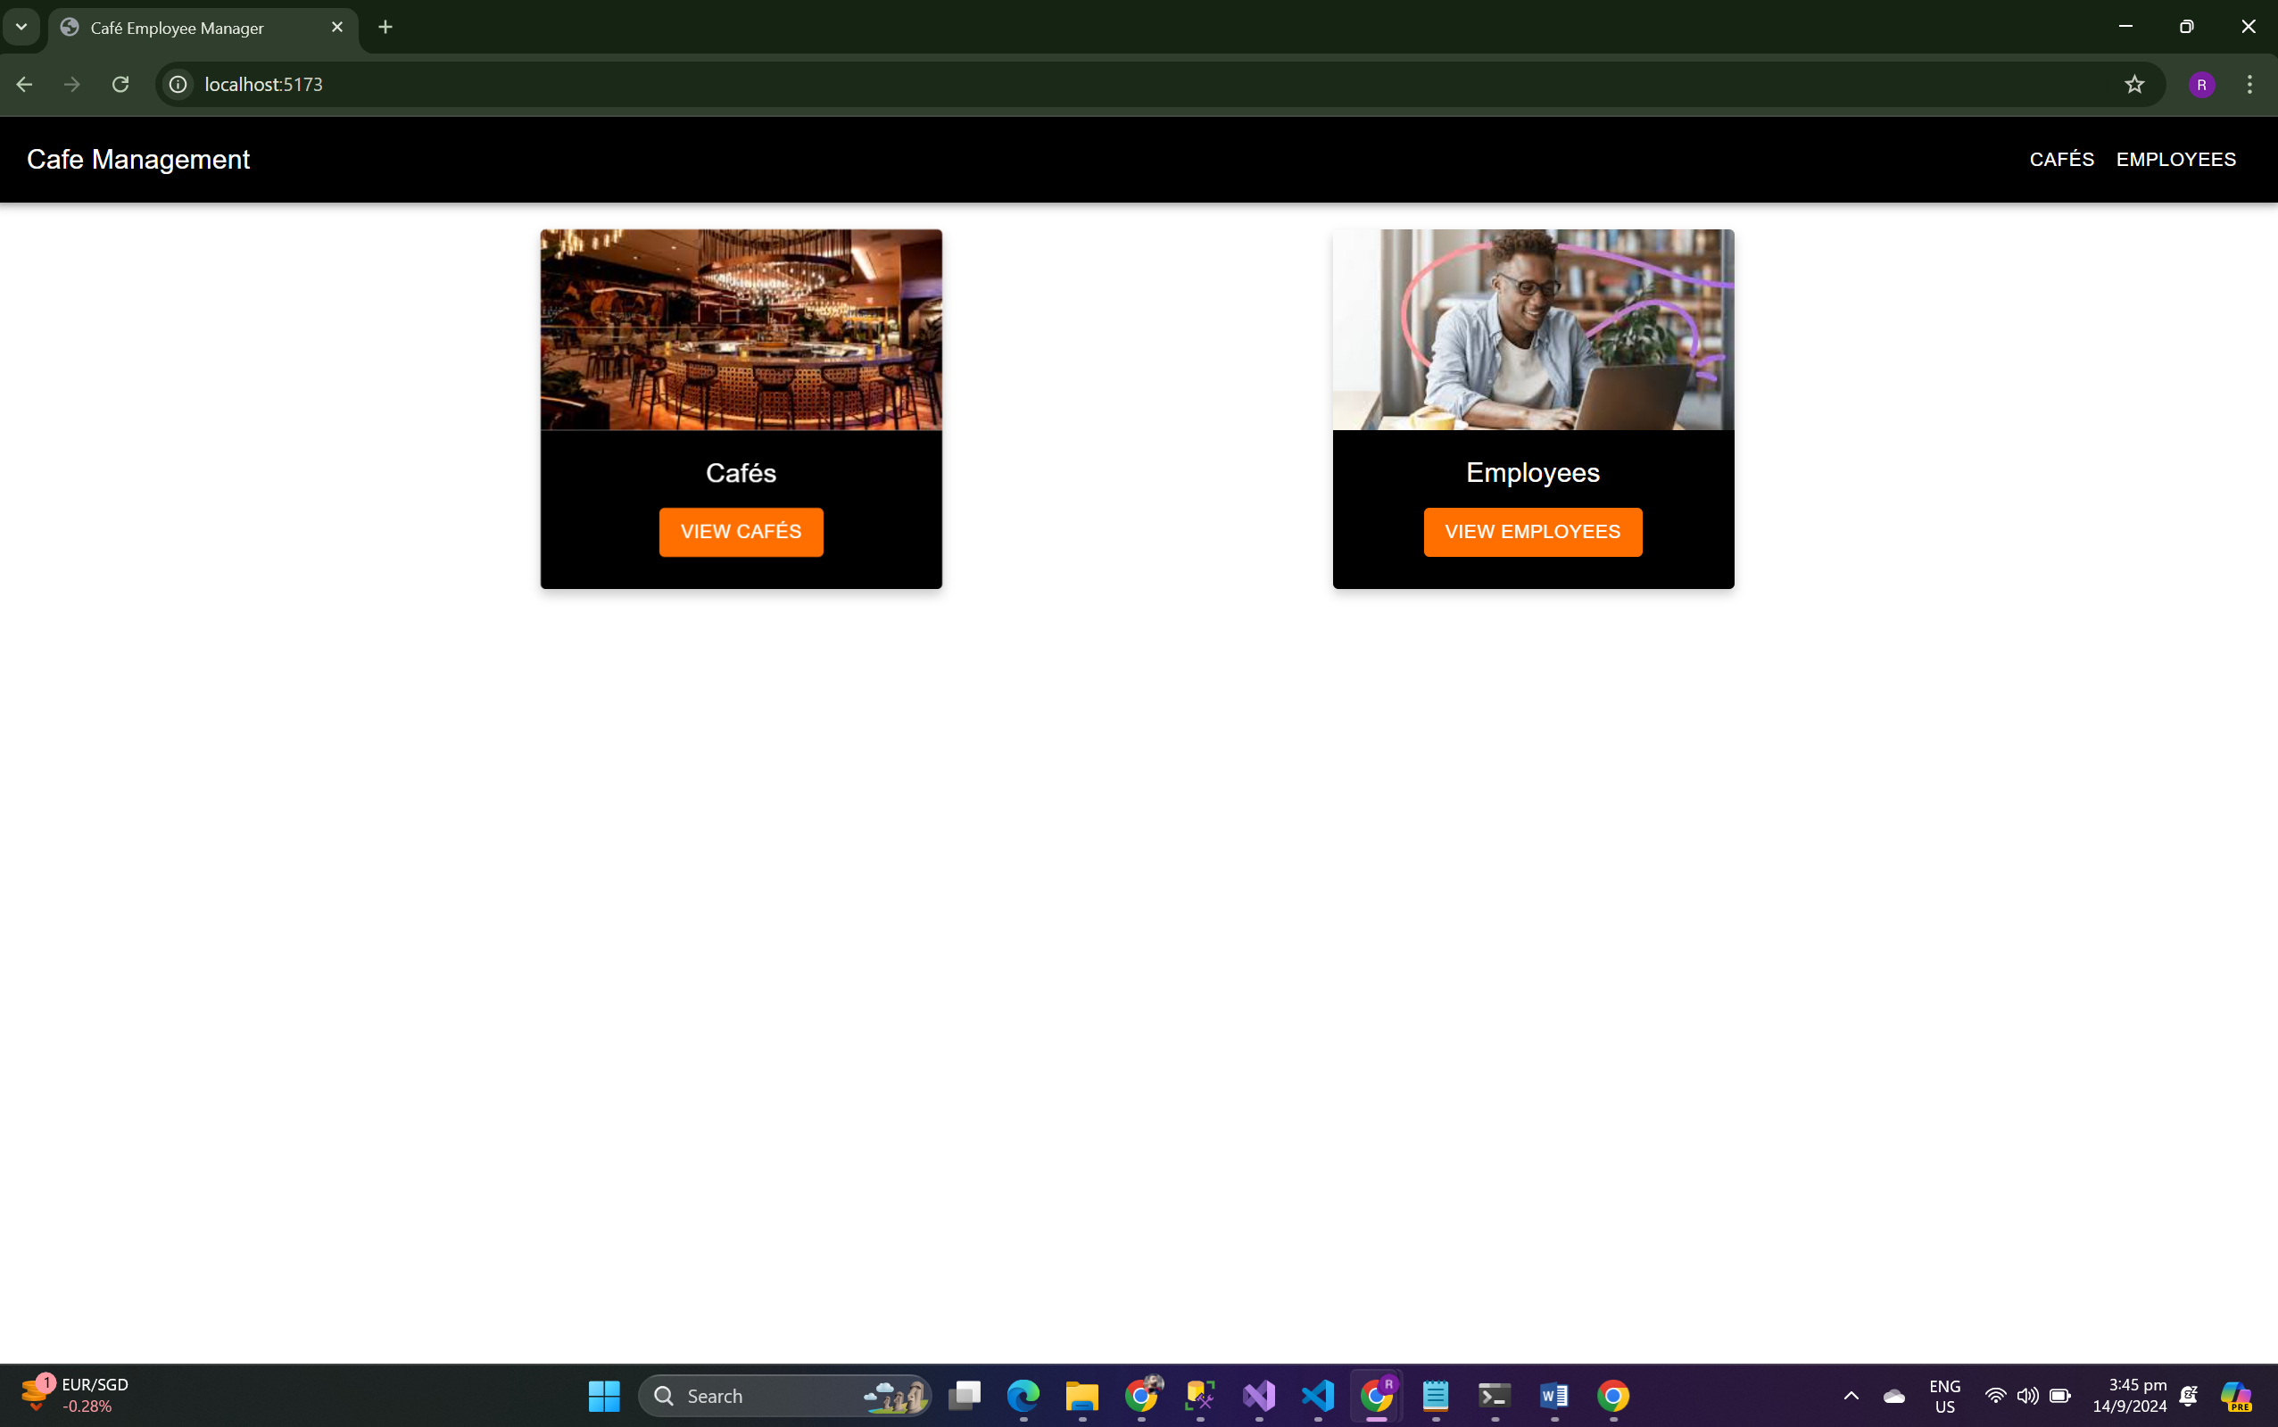

* User can select the Employee and Café page

**Café Page**

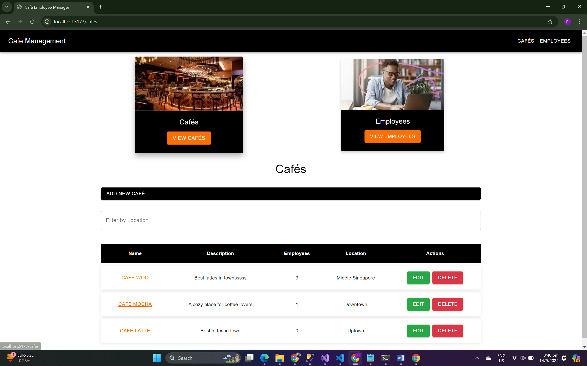

**Café by location  
  
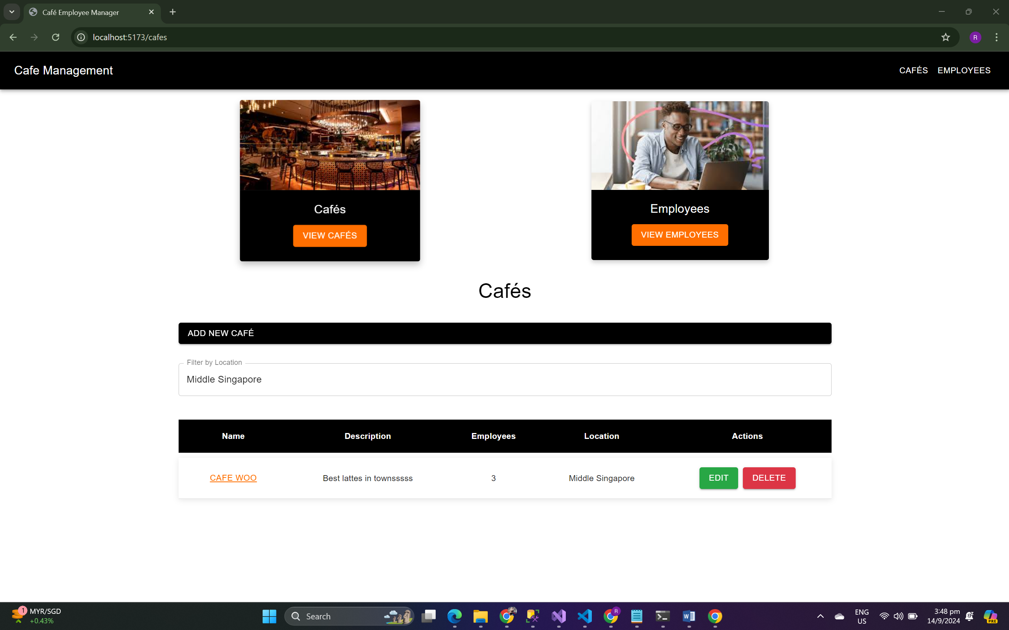**

**Café by Café Name**

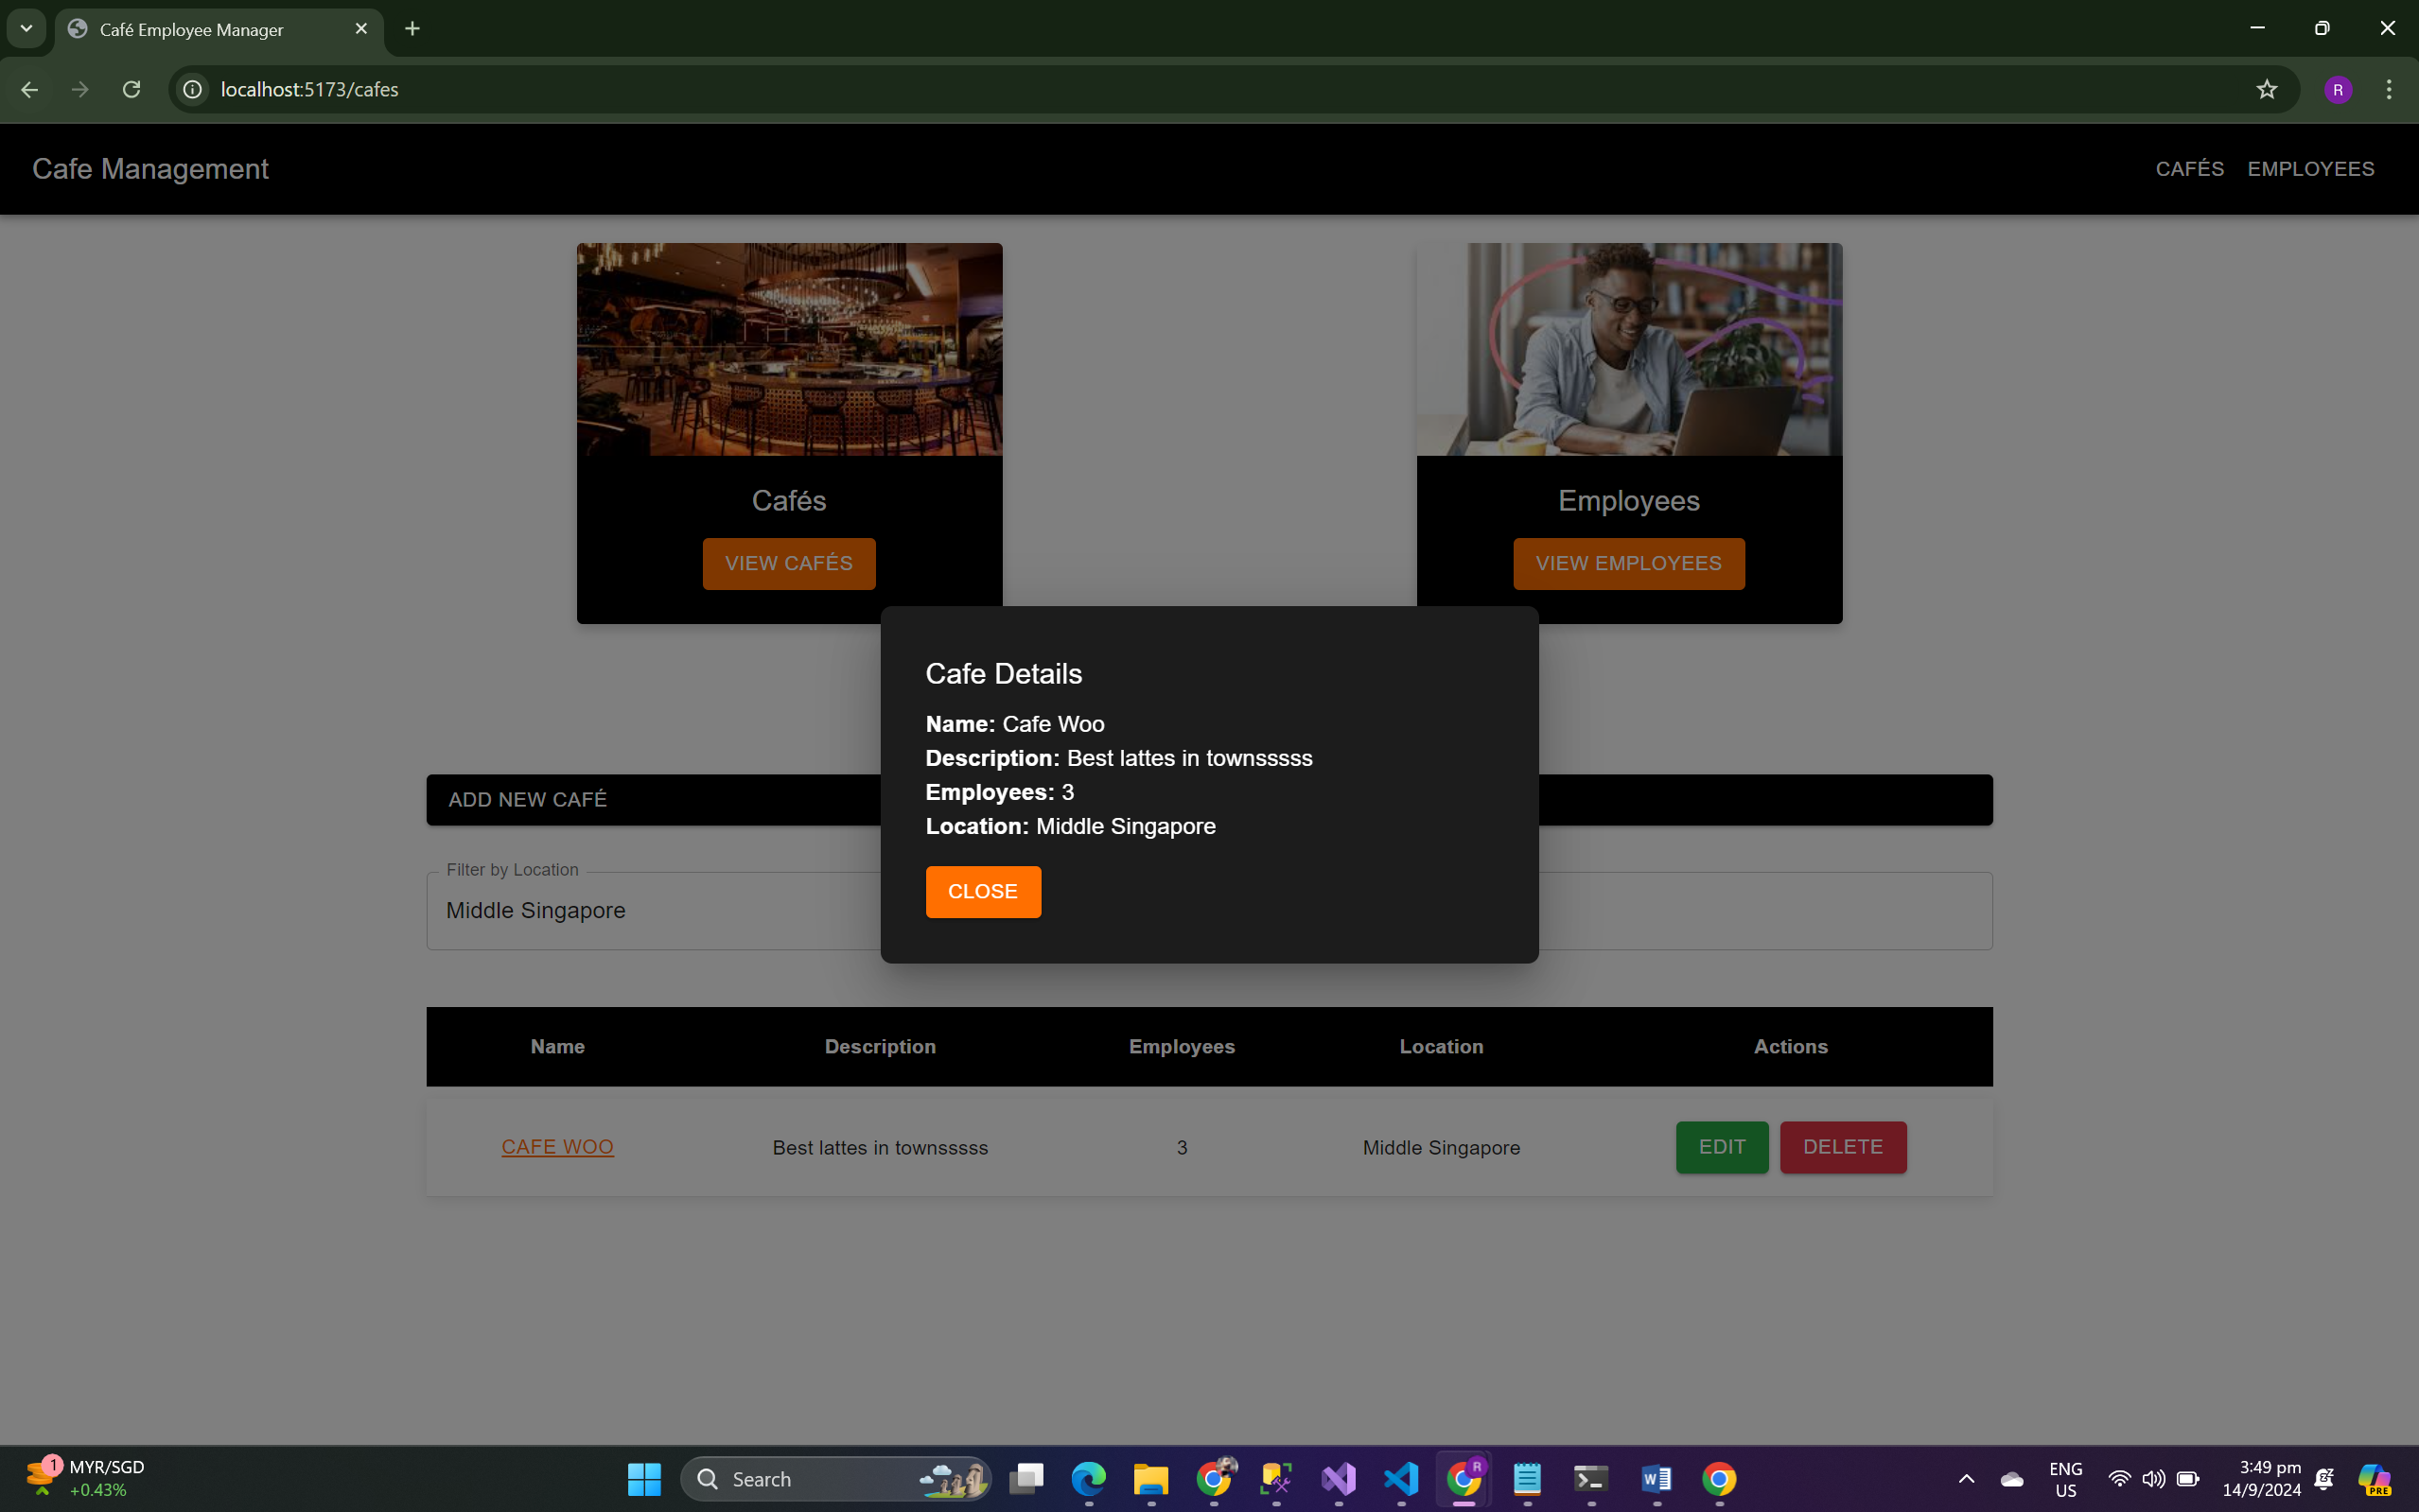

**Add Café  
  
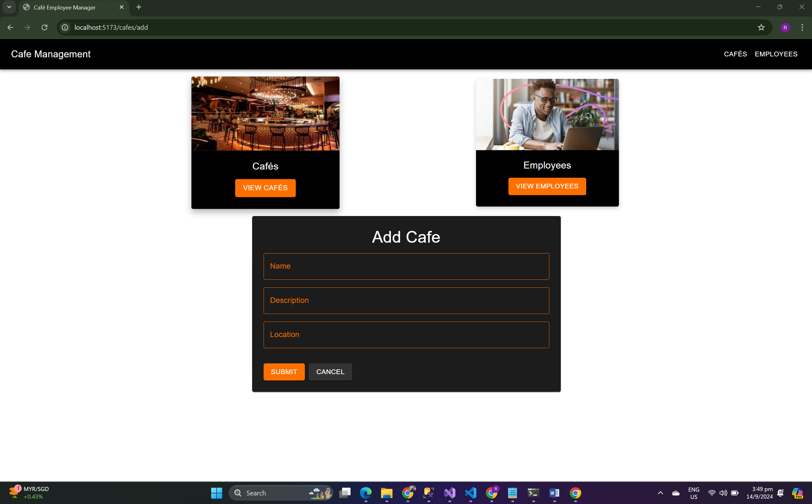**

**Edit Café**

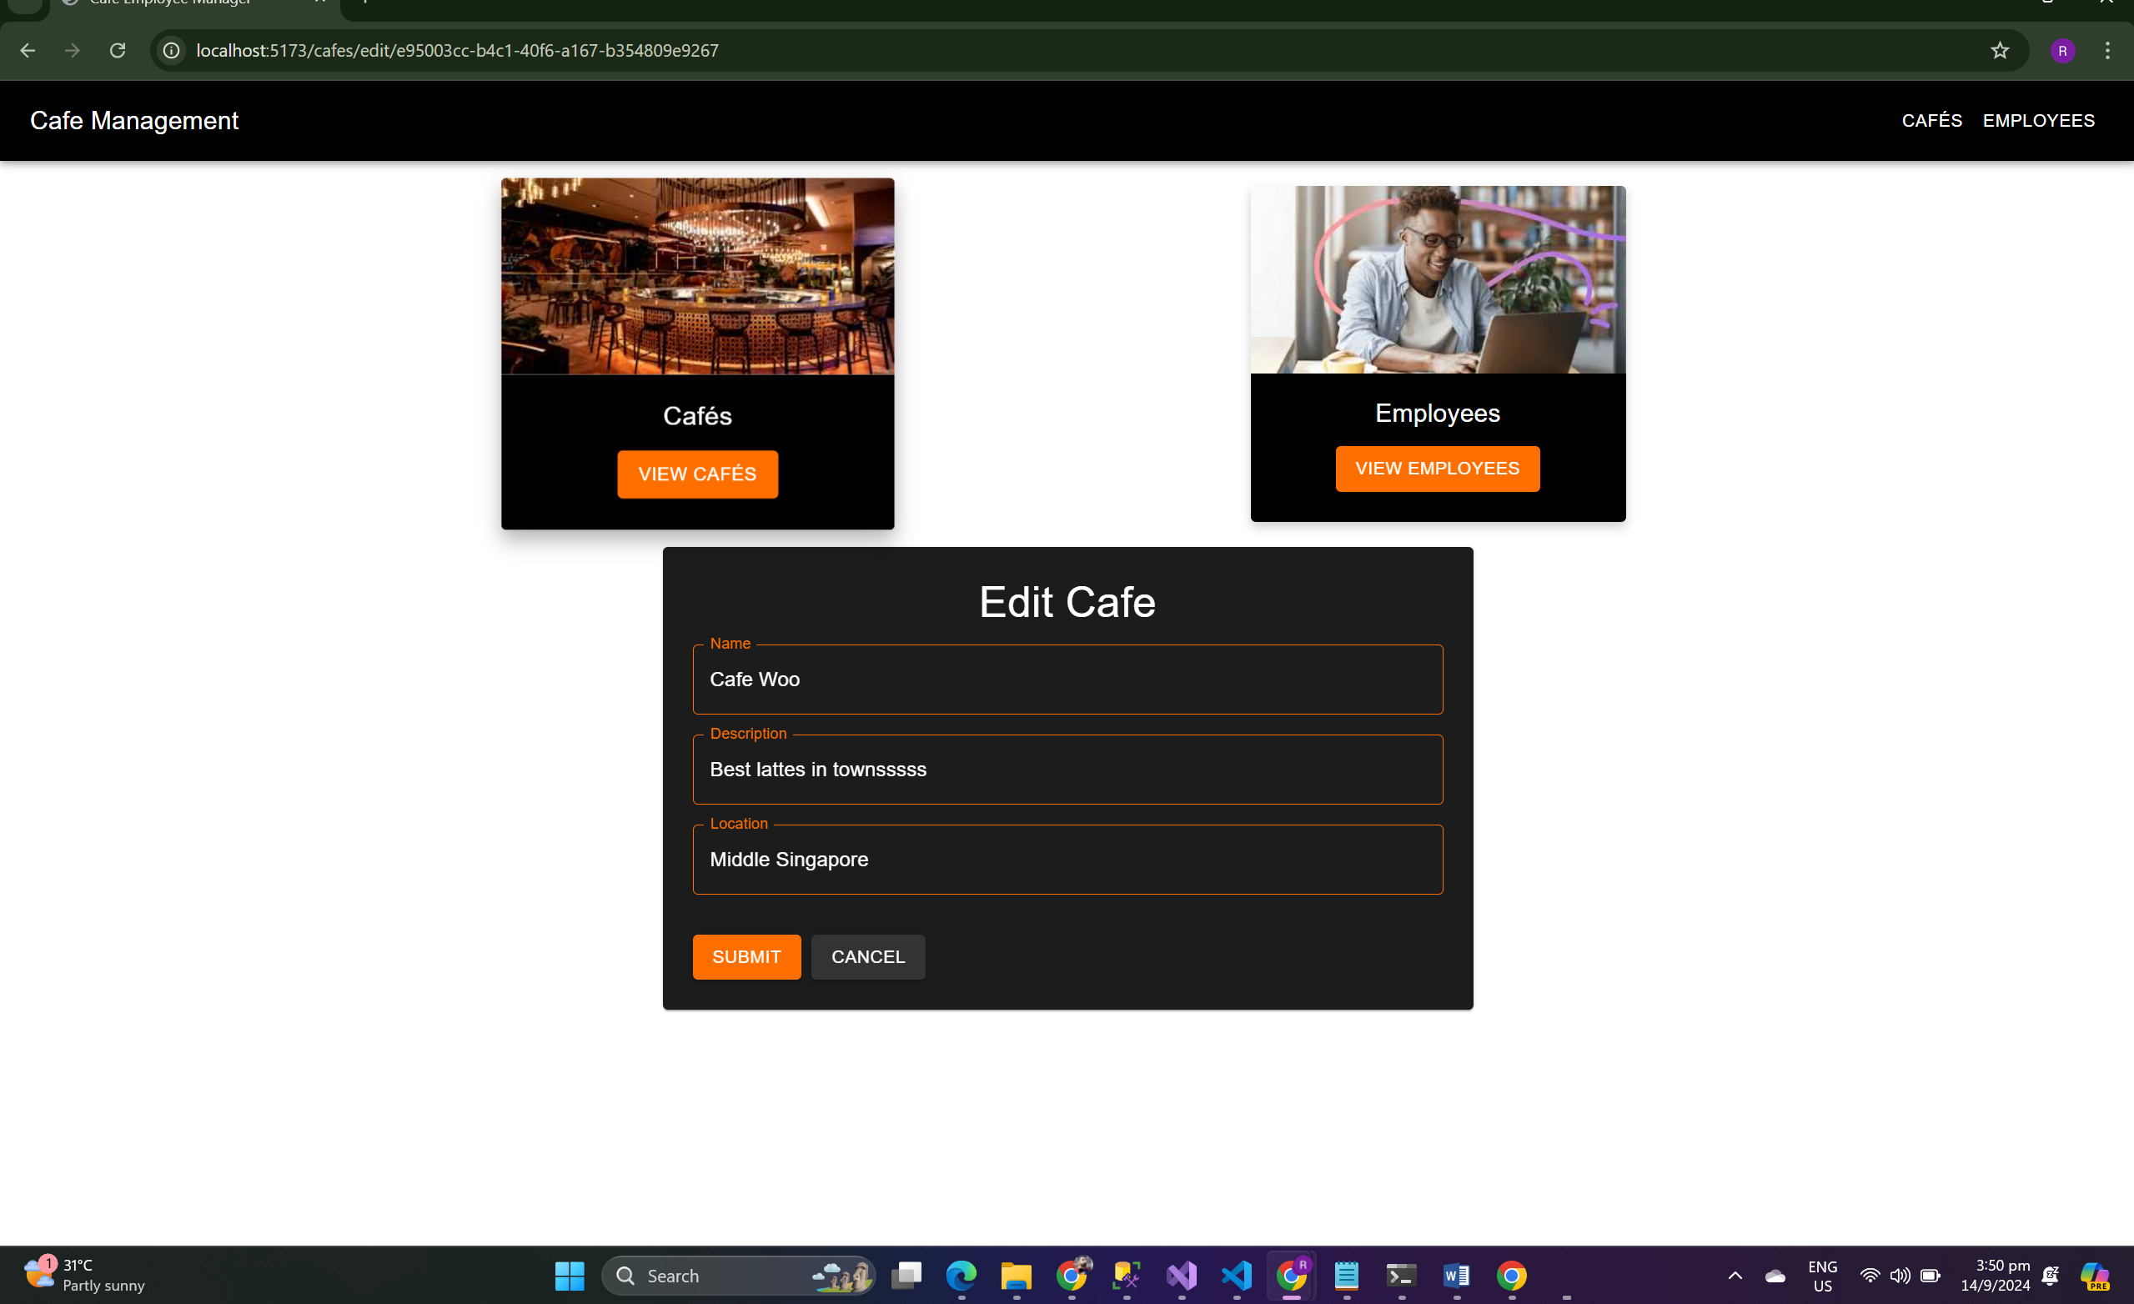

**Delete Café**

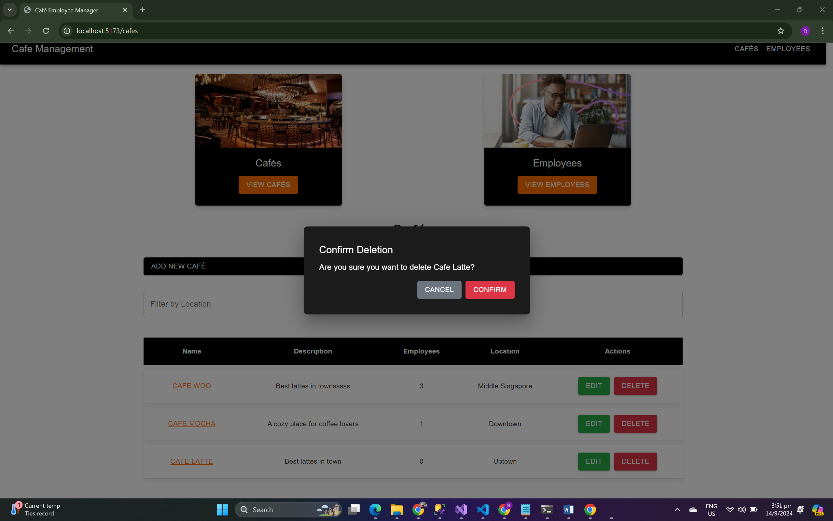

**Employee Page**

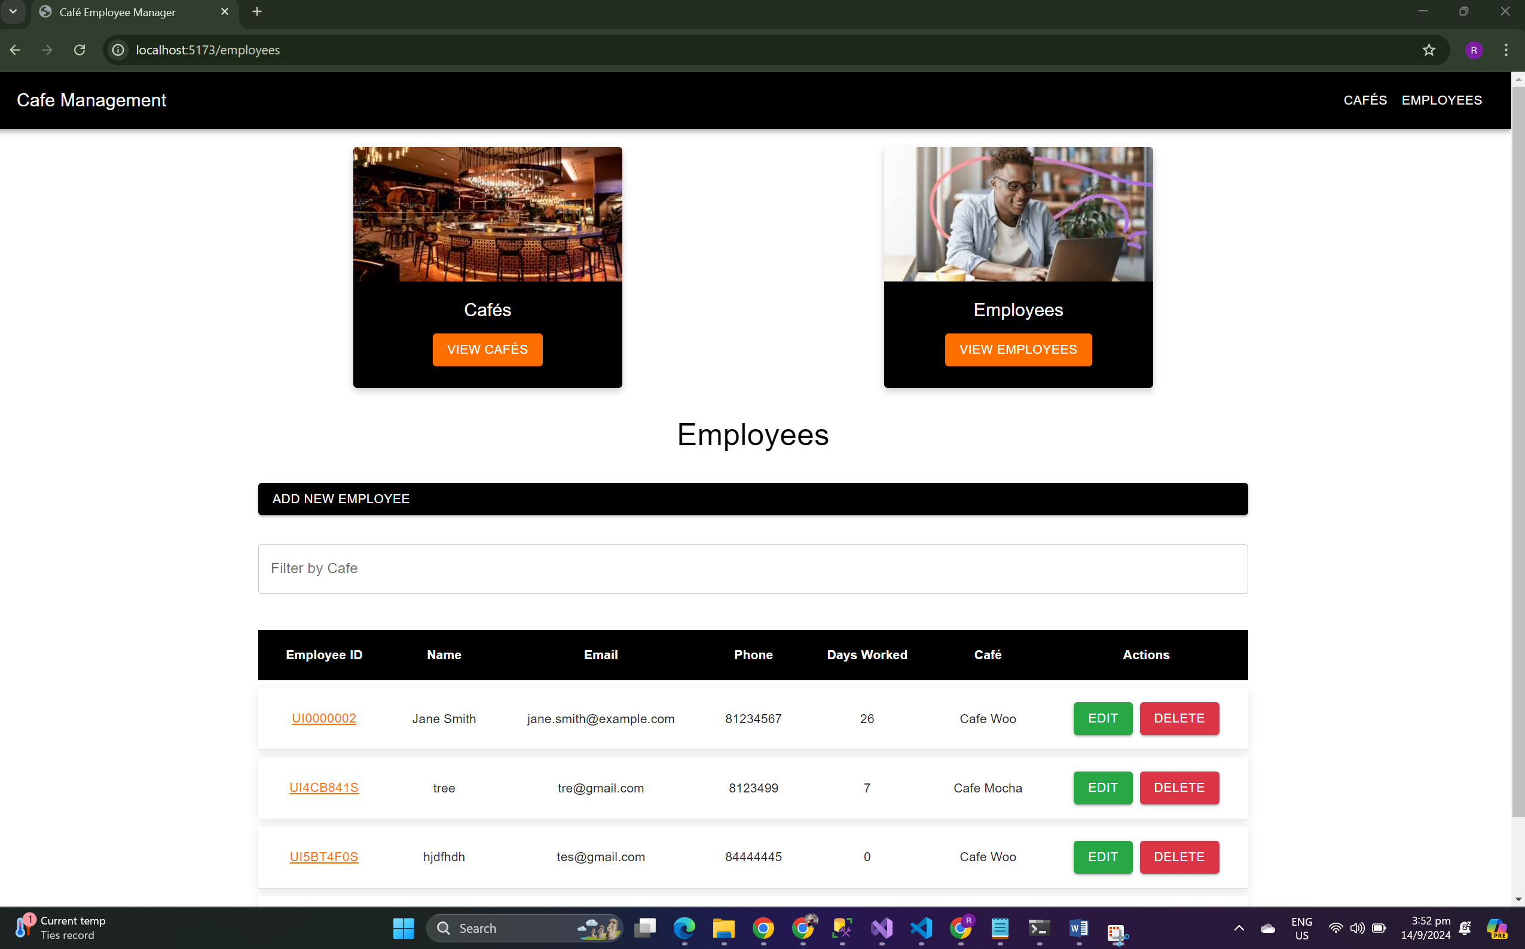

**Employee by Café**

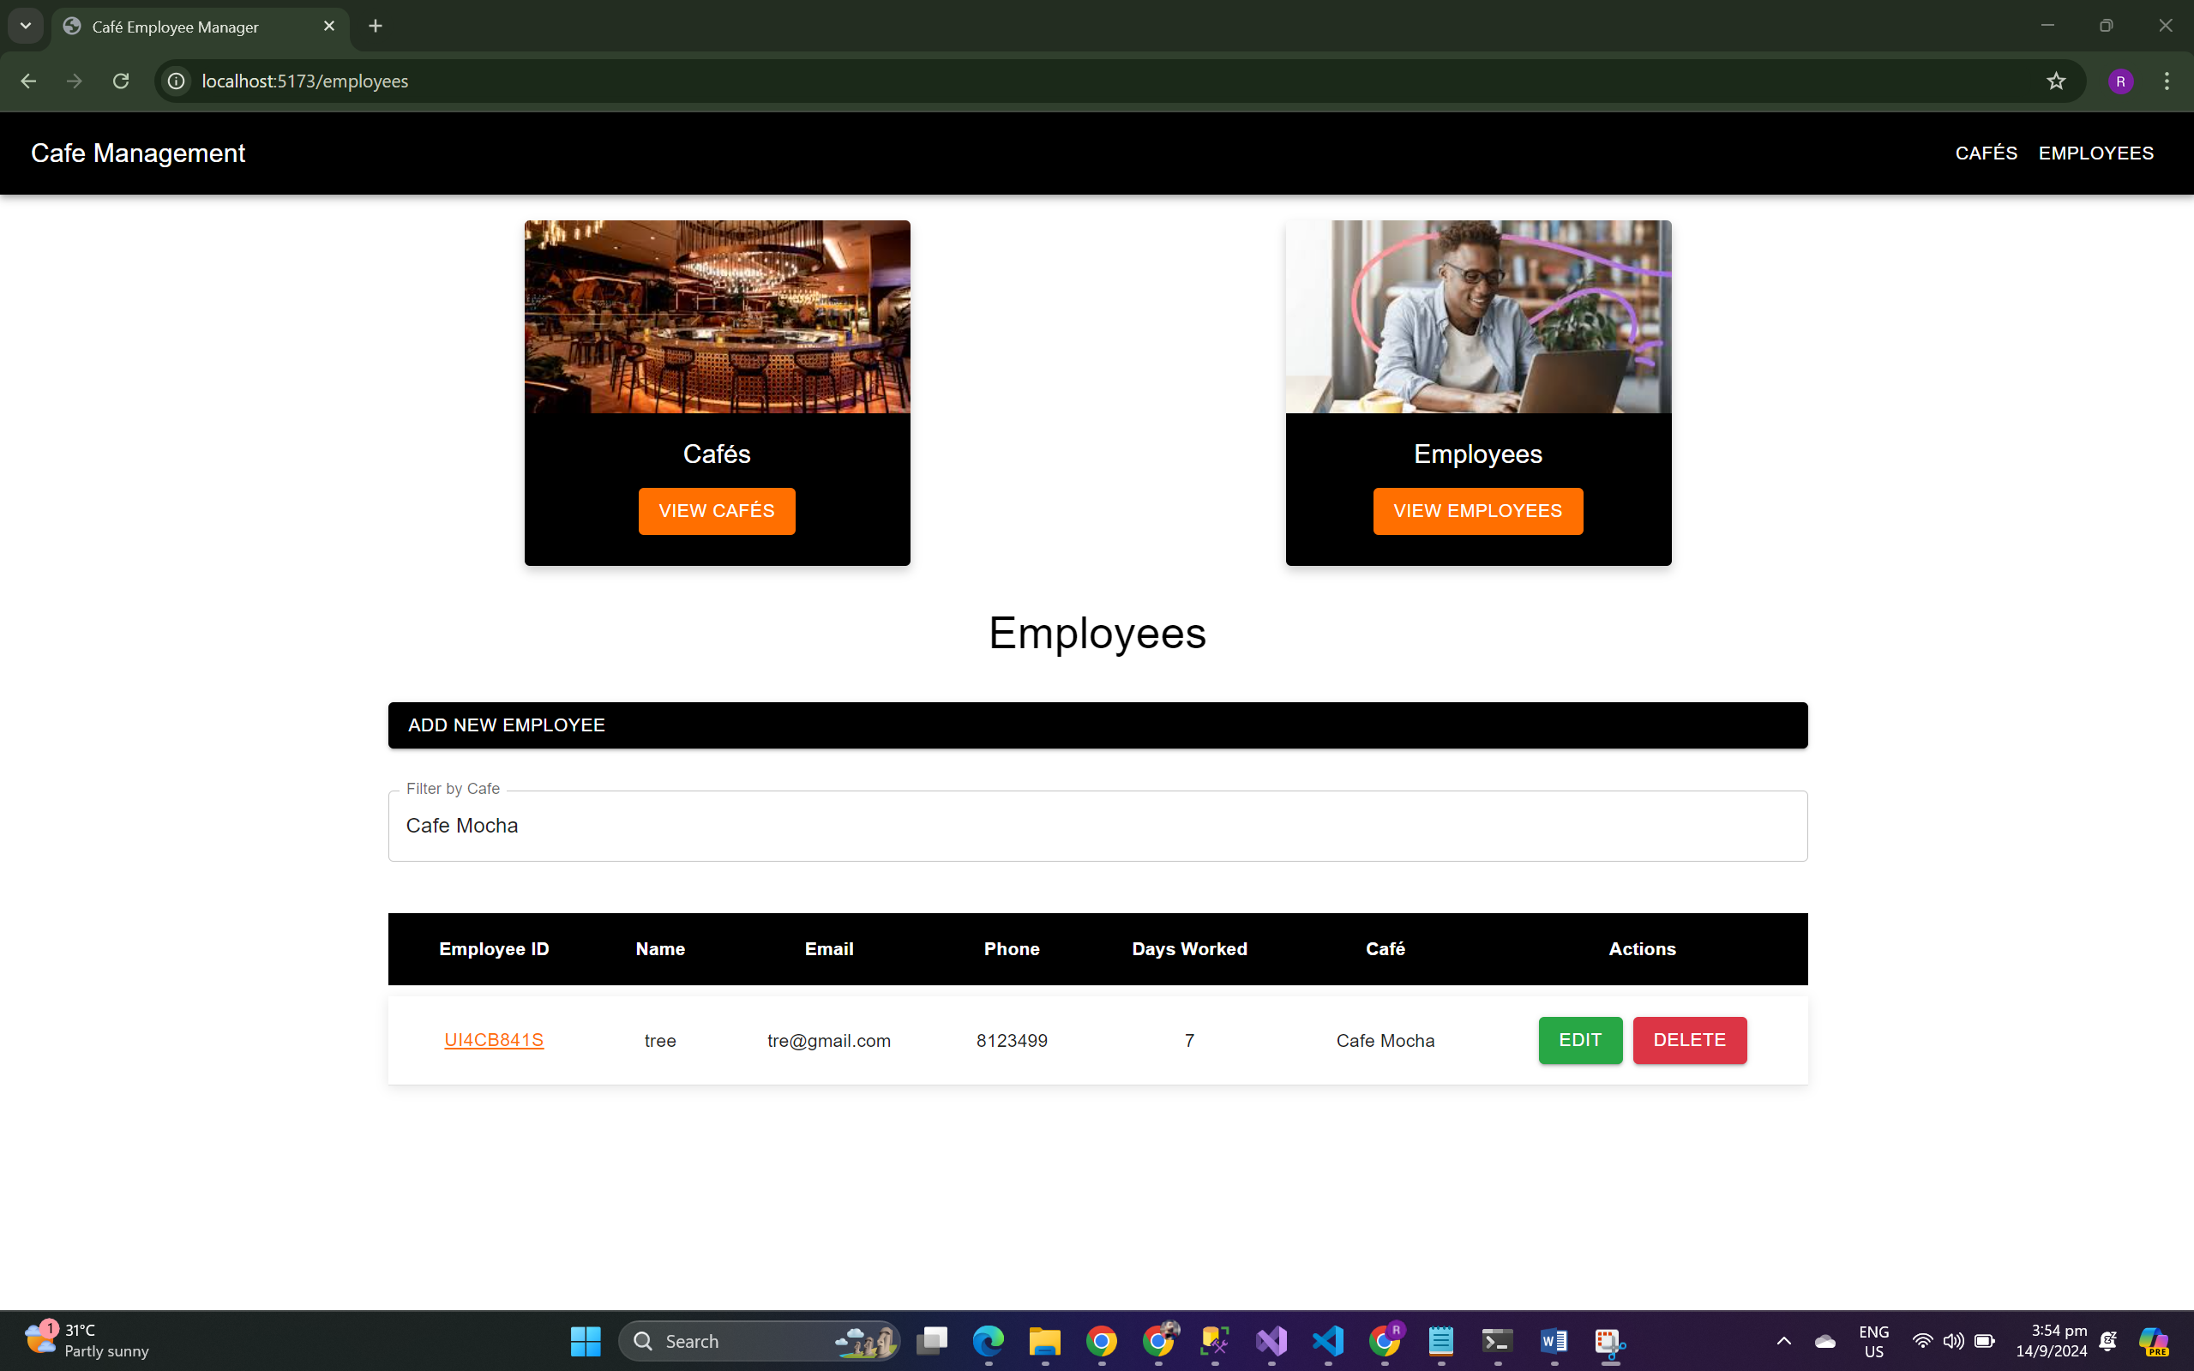

**Employee by EmployeId**

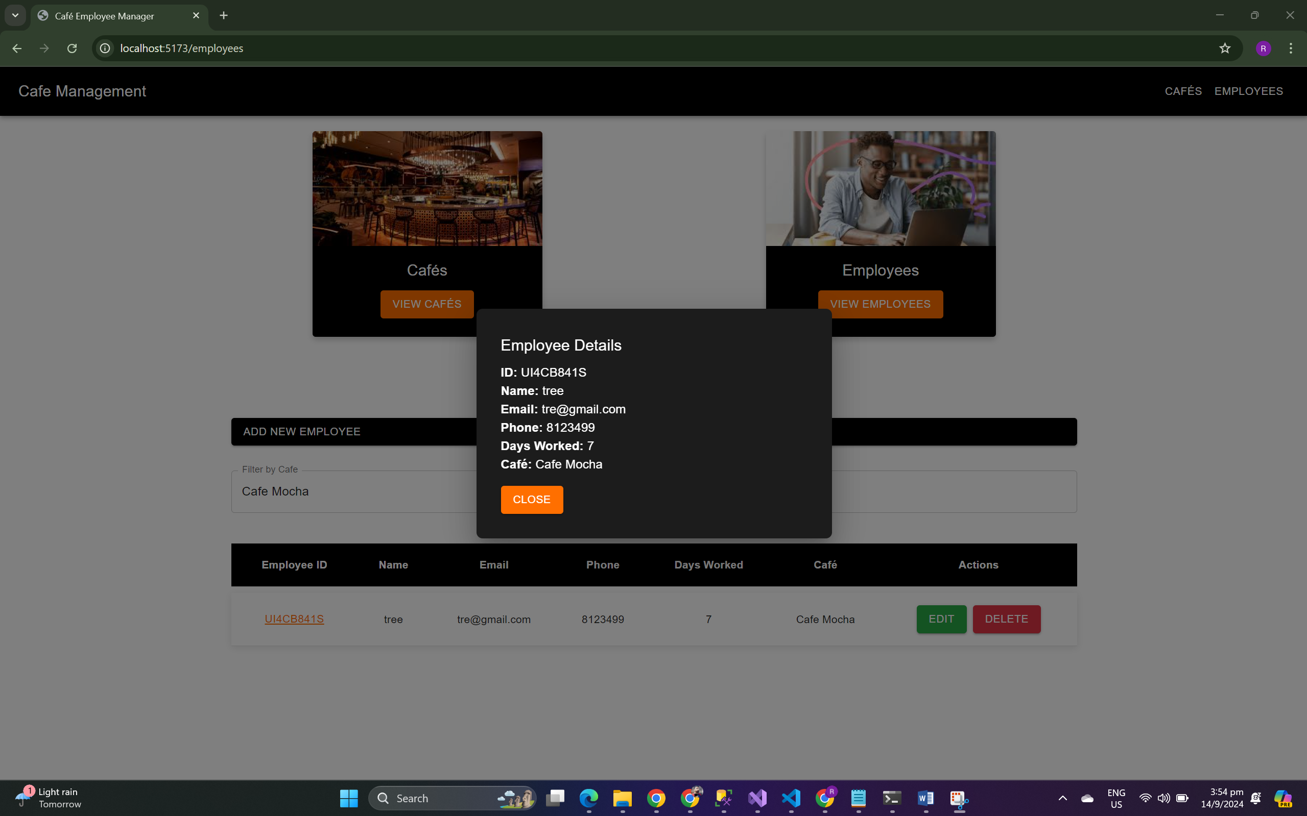

**Add employee**

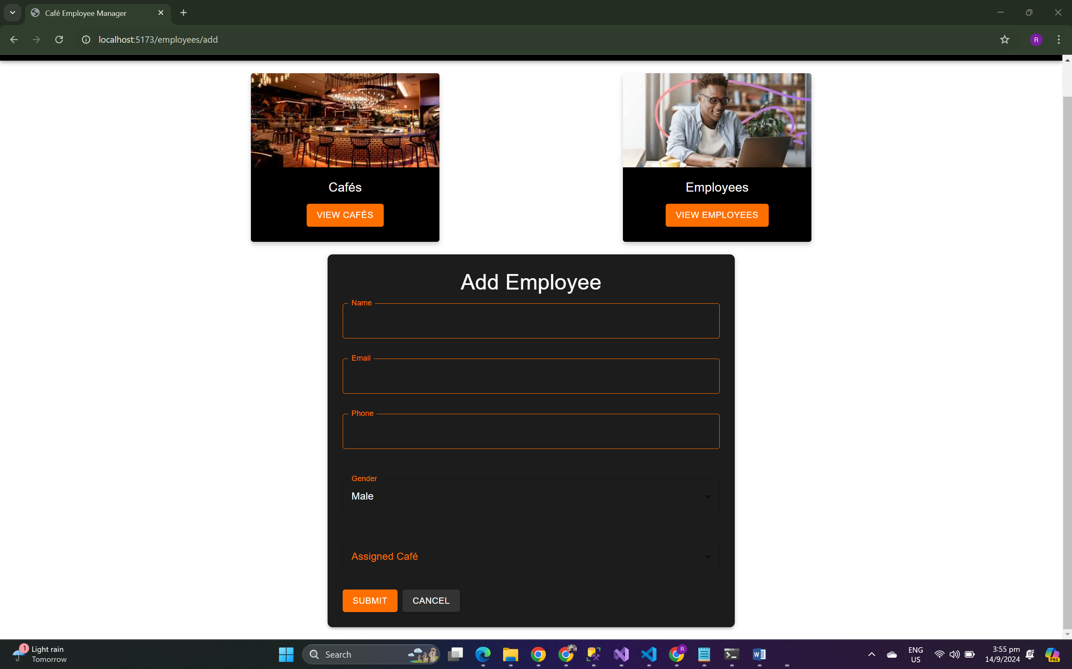

**Edit Employee**

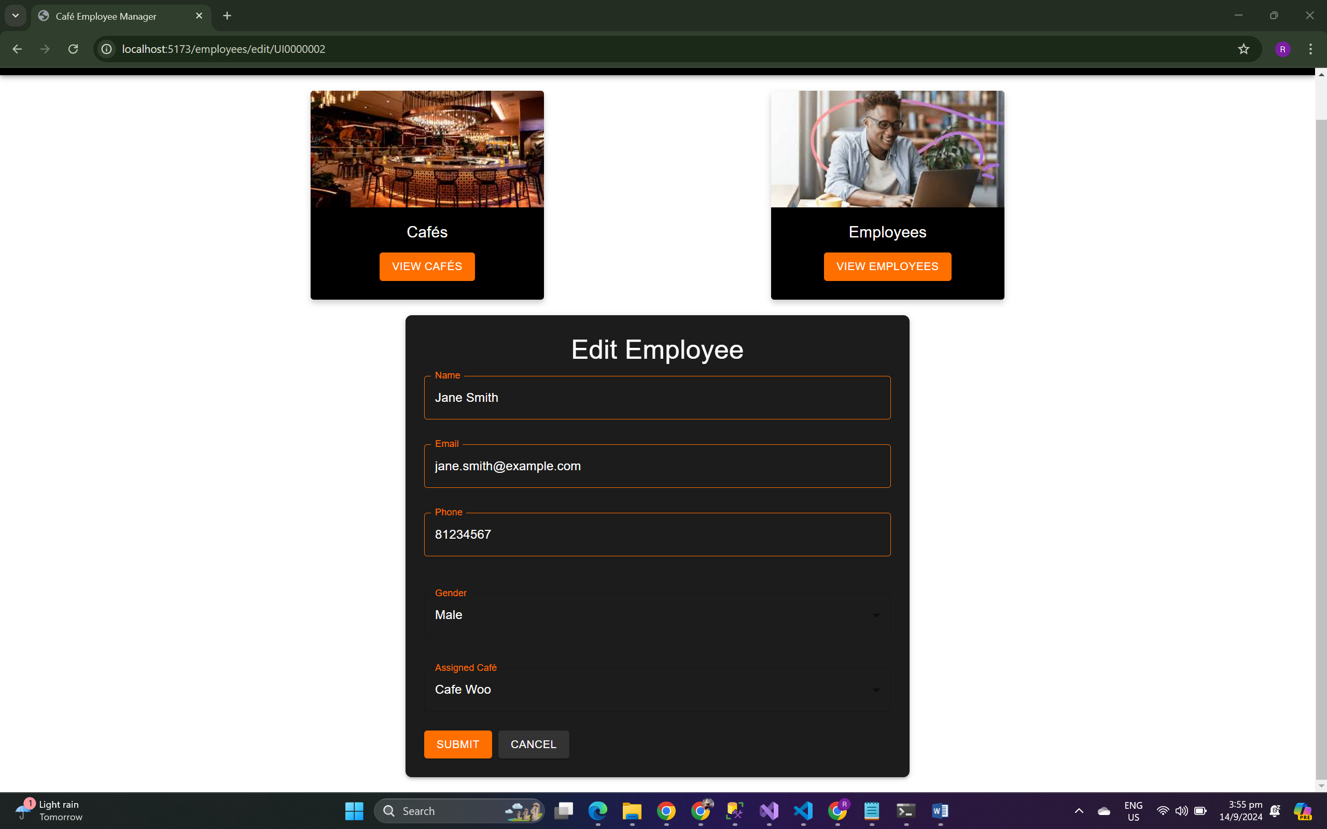

**Delete Employee**

